### What is airflow?

Open souce platform to author, schedule and monitor workflows.

#### Core components

* Web Server - Flask server with Gunicorn serving the UI
* Scheduler - Daemon in charge of scheduling workflows
* Metastore - Database where metadata will be stored
* Executor - Class defining how the task should be executed
* Worker - Process/Subprocess

#### DAG?

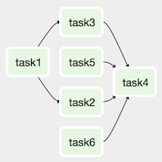

Operator

Ex:-

db = connect(host,crendentials)

db.insert(sql_request)

* Action Operators- CRUD
* Transfer Operators - send data from source to destinations
* Sensor Operator - Waits for a condition to be met before getting triggered

#### Task Instance ?

**When an operator runs inside the DAG, it is called a task instance.**

**How airflow works ?**

**One node architecture**

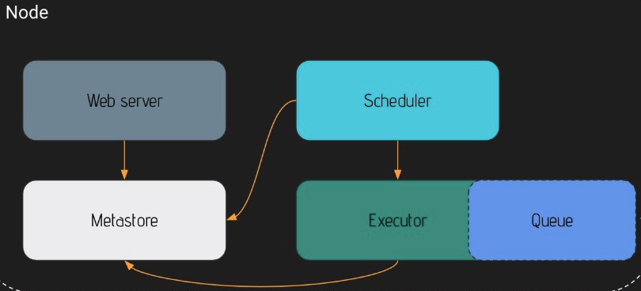

**Workflow -**

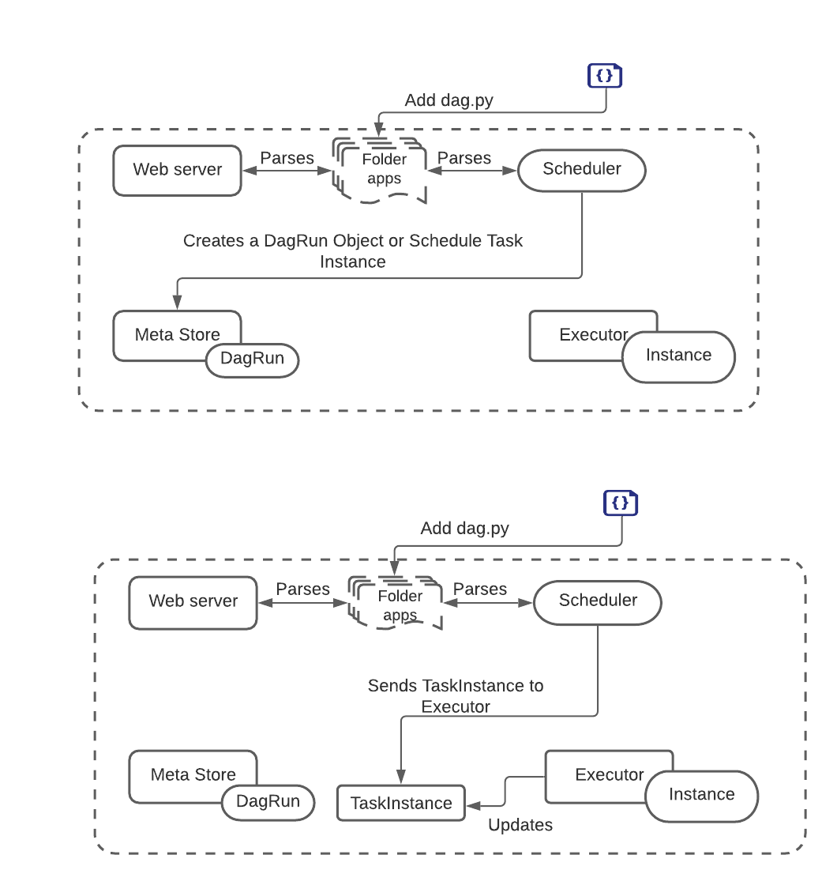

**Installing Airflow**

| docker run -it --rm -p 8080:8080 python:3.8-slim /bin/bash  python -v  export AIRFLOW_HOME=/usr/local/airflow  env|grep airflow |
| --- |

**Docuementation in progress……………………..**